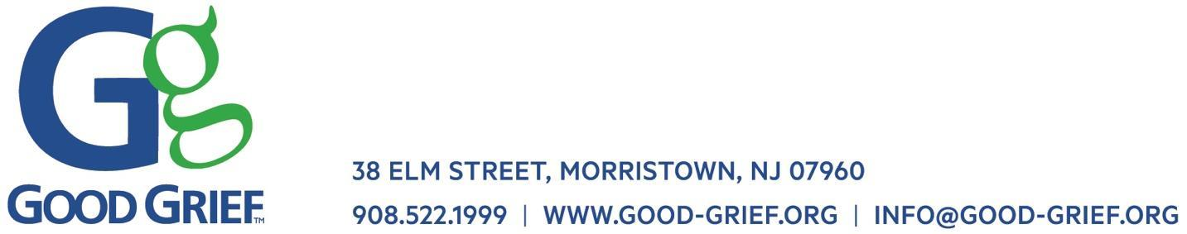

Statement of Planned Giving Intention

As an expression of my commitment to Good Grief’s mission, I declare my intention to provide a gift for Good Grief, Inc. (Tax ID: 20-0514996), as set forth in my will, trust, retirement plan or other estate plan.

The current estimated value of the gift is $__________

I understand this statement does not constitute a legally binding agreement.

My gift is unrestricted and to be used at the discretion of Good Grief, Inc. and its board of directors.
___Yes ___No

If “no,” my gift is designated for the following uses (if more than one designation, please specify
percentages or amounts to each):

To ensure that my wishes are followed, I attach a relevant portion of my will or estate plan for Good Grief’s records and permanent file.

I am comfortable being recognized as a planned giving donor to Good Grief, Inc. and listed as a part of the Good Grief Legacy Circle.
___Yes ___No

If yes, please print your name below exactly as you would like it to appear.

Donor’s Name Printed: _______________________________________

Donor Signature: ___________________________________________

Date: _______________________________________________________

Once completed please return this form to Nicole Hudson at NHudson@good-grief.org.

